Kinematics Equations: Warm-Up
Name: ___________________________________________ Date: ____________________________
- Calculate the acceleration of a car that travels 600 m in 4.5 seconds if it was initially moving with a speed of 8 m/s.

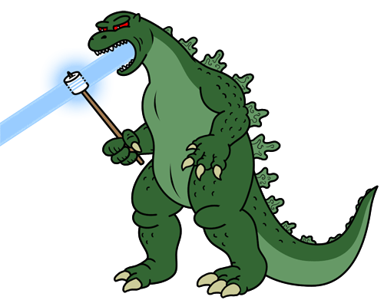
- Calculate the distance Godzilla travelled through the streets of Japan if he had an initial speed of 20 m/s and accelerated at 5 m/s/s until his final speed was 75 m/s.

