Mass, Weight & Density
Name: _____________________________________________ Date: ___________________________
Answer the following questions based on your reading and the notes you took from class.
$W=F_{g}= mg$ $1 kg = 2.2 lbs$ $D=\frac{m}{V}$
where $g$= the acceleration due to gravity

Thinking, Inquiry and Problem Solving
- a) Write your mass in pounds: ____________________________.
b) Convert this weight into kg.

c) Calculate your weight in Newton’s on Earth?

d) Calculate your weight in Newtons on the moon where the acceleration of gravity is 1.67 m/s/s.

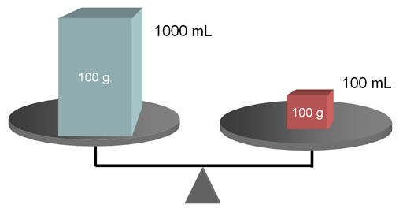
- Which way would the balance tip? Explain. Use this example to explain the difference between mass and volume. Which object is denser? Explain how you know this.

- The density of a steel object on Earth was found to be 0.564 kg/cm³. If you had a block of this object with dimensions 23 cm x 8 cm x 3 cm.

- Calculate the volume of the block ($l×w×h$) in cm³

- Using the volume calculate the mass since you know the density.

- Determine the weight (in Newtons and pounds) of this object if it were taken via a spaceship to a new planet where the acceleration of gravity is only 5.4 m/s/s.

- The weight of an object on the surface of Earth is 230 N. The density of the object is 2.34 kg/m³. Calculate the volume of the object in m³.

